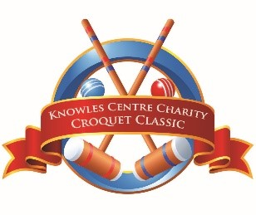
I want to be a part of the 2022 Charity Croquet Classic!
My support will provide essential repairs, renovations, and refresh of Knowles Centre’s Healing Homes.
2022 Sponsorship Opportunities
☐ YES! I want to sponsor the 2022 Knowles Centre Croquet Classic at the following level (each level includes 1 team registration)

☐ Presenting Sponsor $5,000
☐ Dinner Sponsor $3,500
☐ Speaker Sponsor $2,500
☐ Prize Sponsor $2,000 (2 available)
☐ Cocktail Sponsor $1,500
☐ Court Sponsor $1,200 (2 available)
☐ Refreshment Sponsor $500
☐ Decor Sponsor $500
2022 Other Opportunities
☐ I would like to support Knowles Centre in the following way(s):
☐ A prize donation of
☐ I would like to help with a Gift-In-Kind of
☐ I am donating $
☐ I would like to register a team ($400) (4 available in addition to sponsor teams)
Name of Organization:
Contact Name: Phone
Mailing Address:
City: Province _________________ Postal Code:
Email:
I/we wish to be recognized as
☐ Please invoice me ☐ email to or ☐ mail
☐ I have enclosed a cheque payable to Knowles Centre Inc.
☐ I would like to pay by credit card; please email the payment link to
In the event of Knowles Centre’s Croquet Classic being cancelled, sponsors and guests will be contacted by a member of our team via phone. You will be given the opportunity to transfer your purchase to a donation to Knowles Centre for a charitable receipt, carry over your purchase to the following year, or have a refund issued. If you have not responded to Knowles Centre within 30 days, we will assume you wish to transfer your sponsorship to a donation, and we will issue you a charitable receipt.
Knowles Centre Inc. respects your privacy. Your information is collected to administer transactions and meet donor expectations. Charitable Registration No: 118984624 RR0001

